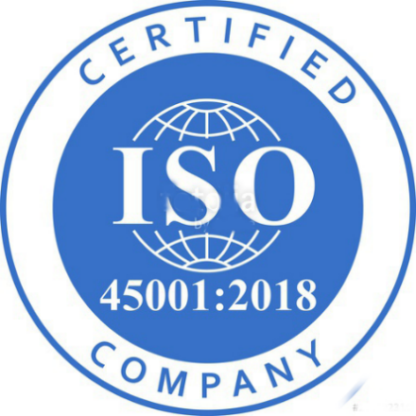

WHY BE CERTIFIED?

How to be effective in today’s HealthCare services

Author

Tarek F. Tawil, DC (Neuro), CIRSTM, CICETM

Physician & Chief Executive Officer Zygos Health

AMA Guides 5th & 6th Edition

Functional Medicine Hyperbaric Practitioner (IBUM)

ISO 45001:2018 OSH/HIPAA Certification: Lead Auditor

**Occupational Health and Safety (OHS) Management System (ISO 45001:2018)**

The implementation of an Occupational Health and Safety (OHS) Management System such as that accredited to the ISO 45001:2018 standard can be the key to the successful management of health and safety within any organization.

ISO 45001:2018 provides an established framework that can be developed to provide a full Safety Management System that can be used to monitor and improve working practices. It is a management tool that should be implemented through all levels of the organization to help achieve the objectives of the organization.

Achieving ISO 45001:2018 can help to demonstrate that a healthcare services company has management policies and associated procedures in place to enable them to consistently achieve the standards set out by their clients.

ISO 45001 has been designed to be compatible with other management system standards and specifications, like ISO 900 QMS and ISO 14001 Environmental. There is a significant amount of commonality between the standards which lends itself to the development of one Integrated Management System.

Comments: